SaradarVallabhbhai Patel Institute of Technology, Vasad
Information Technology Department
Question Bank – For Mid Semester Exam
Data Structures [2130702]
Introduction to Data Structures
- Define Data Structure? List the various linear and non-linear data structures and explain them in brief. Also state the difference between them.
- Define Algorithm?
- Differentiate between Primitive and Non-Primitive Data Structures.
- Discuss the parameter on which efficiency of an algorithm is defined.
- Define term Data Type?
- What does Abstract Data Type mean?
- Explain static and dynamic memory allocation techniques.
- Determine worst case time complexity of the following program segment.
for i=1 to n
for j=1 to n
for k=1 to j
a=1;
end
end
end
- Explain the following terms with its graphical presentation.
- Big Oh (O)
- Omega (Ω)
- Theta (θ)
Array
- Explain the term sequential organization with its properties.
- Each element of an array Data[20][50] requires 4 bytes of storage. Base address of Data is 2000. Determine the location of Data[10][10] when the array is stored as : (i) Row Major, (ii) Column Major
- Given a two dimensional array A[2:9,9:18] stored in column major order with base address 100 and size of each element is 4 bytes. Find address of the element A[4,12].
Stack
- Write an algorithm for Push, Pop and Empty operations on stack.
- What is recursion? What care should be taken in writing recursive function? Give example for each type of recursive function. Write a C program for GCD using recursion.
- Give difference between recursion and iteration.
- What is Tower of Hanoi(TOH)? Explain it with n=3.

- A recursive function “f” is shown below. What is the value of f(5)?
int f(int x)
{
if(x<2)
return(1);
else
return f(x+1)+f(x-2);
}
- Write an algorithm to convert infix expression to postfix expression.
- Consider the following arithmetic expression. Written in postfix notation. Translate it into infix notation and evaluate.
- 12,7,3,-,/,2,1,5,+,*,+
- 5 4 6 + * 4 9 3 / + *
- AB+CD/*GH*+ where (A=2,B=4,C=6,D=3,G=8,H=7)
- Convert following infix expression to postfix and prefix expressions.
- A/B$C+D*E/F-G+H
- (A+B)*D+E/(F+g*D)+C
- (a+b^c^d)*(e+f/d)
- Translate the following string into Polish notation and trace the content of stack.
- A-(B/C + (D%E*F)/G)*H
- A+B^C^D-E*F/G
- Evaluate the following prefix expression.
+*AB-C+C*BA
- Give the data structure to implement two stacks in same array. Write function to implement Push operation on both the stacks.
- How we perform conversion from infix to prefix? Explain with suitable example.
- How we perform conversion from postfix to prefix? Explain with suitable example.
- How we perform conversion from postfix to infix? Explain with suitable example.
Queue
- Explain Following
- Priority Queue
- Circular queue
- Dequeue
- Write a program to perform insert and delete operation of circular queue.
- What do you mean by FIFO and LIFO?
- Consider the following queue, where queue is a circular queue having 6 memory cells.
Front = 2, Rear = 4
Queue : _ , A,C,D, _ , _

Describe queue as following operation take place
F is added to queue
Two elements are deleted from queue
R is added to queue
S is added to queue
Two elements are deleted from queue
B is added to queue
E is added to queue
- List the uses of queue.
Linked List
- Write a program to count number of nodes in a linked list.
- Write an algorithm/program to implement following operations in the “Singly Linked List”
- Insert the node at end.
- Delete node whose value is “Y”.
- Write an algorithm to delete the last node from a singly linked list.
- Write an algorithm to delete node from doubly linked list.
- Write an algorithm for inserting element in and deleting element from circular queue.
- Write an algorithm that will concatenate two circular linked lists, producing a circular linked list.
- Write the implementation procedure of basic primitive operations of Queue using linked list.
- Write an algorithm to implement ascending priority queue using singular linear linked list which has insert() function such that queue remains order list. Also implement remove() function
- Define sparse matrix. Briefly explain representation of sparse matrix with the help of list and array.
- Compare: (1) Linked -list and Array (2) Circular queue and Simple Queue.
- What will be the output of a given function for a following input list?

first->[1]->[2]->[4]->[8]->[10]->NULL

void f1(struct node *first)
{
if(first==NULL)
return;
f1(first->next);
printf(“%d\n”,first->info);
}
Tree
- Define Tree.
- Discuss following with reference to tree
- Root
- Parent
- Child
- Path
- Degree of Node
- Ancestors
- Descendants
- What do you mean by Binary Tree.
- Answer the following: The Height of a binary tree is the maximum number of edges in any root to leaf path. Define the maximum number of nodes in a binary tree of height “h”.
- Draw all possible binary tree with 3 nodes(vertices).
- Draw all possible binary trees T where T is 2-ary tree with 4 leaf(external) nodes.
- Show that maximum number of nodes in the binary tree of height “h” is (2^(h+1))-1.

- Explain array representation of binary tree using the following Fig. And Explain limitation of this representation.
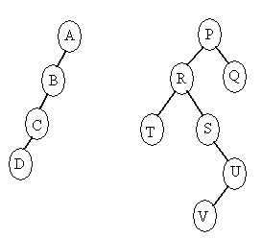
- (b)

- Convert following General tree to Binary tree.
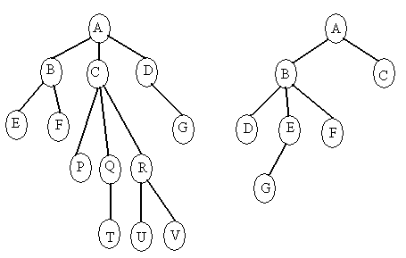
- (b)

- Discuss with respect to tree.
- Strictly Binary Tree
- Complete Binary Tree
- Full Binary Tree
- Almost Complete Binary Tree
- Binary Search Tree

- Give traversal order of following tree into inorder, preorder, and postorder.
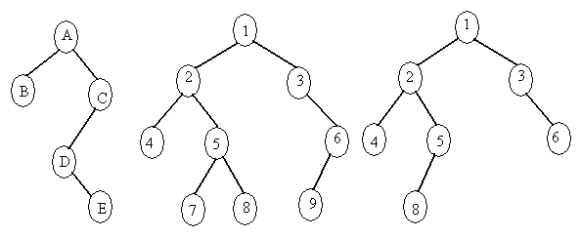
- (b) (c)

- Construct a binary tree for the following give order sequences
- Inorder : DGBAHEICF Postorder : GDBHIEFCA
- Inorder : ABCDEFGHI Preorder : FBADCEGIH
- Construct binary search tree for following data:
10,3,15,22,6,45,65,23,78,34,5
Find its Inorder, Preorder, Postorder traversal sequences
- Insert the following in binary search tree.
- 7,39,-2,0,3,42,20,5,40
- 15,16,5,10,8,19,4,6,17,5,21,18,10,15,6

